Sample Final Exam Question

1. Suppose the rule of the party is that the participants who arrive later will leave earlier. Which data structure is appropriate to store the participants?

A. Stack

B. Array List

C. Linked List  
D. All of the above

answer: A

1. Suppose your program frequently tests whether a DVD is available in a set of sorted DVDs. Among the following, which is the best solution?
2. Store the sorted DVD records in a Linked List and use binary search
3. Store the sorted DVD records in an Array List and use binary search
4. Store the sorted DVD records in an Array List and use sequential search
5. Store the sorted DVD records in a Linked List and use sequential search

answer: B

1. Which of the following is the correct way to instantiate an array of 10 generic objects?
2. T[] x = new T[10];
3. T[10] x = new T[];
4. T[] x = (T[])(new Object[10]);
5. None of the above

answer: C

1. A linked implementation of a stack adds and removes elements from the _______ of the linked list.
2. Front
3. Rear
4. Middle
5. None of the above

answer: A

1. What is the output of the following program

**public class recurse2**

**{**

**public static void main (String[] args)**

**{**

**recurse(3);**

**System.out.print("---");**

**recurse(2);**

**}**

**public static void recurse(int x)**

**{**

**if (x<=1)**

**System.out.print("***");**

**else if ((x % 2) == 0)**

**{**

**System.out.print("+++");**

**recurse(x-2);**

**}**

**else**

**{**

**System.out.print(x);**

**recurse(x-1);**

**}**

**}**

**}**

1. 3***+++***---+++
2. 3+++***---+++***
3. 3*******++++----
4. None of the above

answer: B

1. Consider the following statements:

**int[ ] p = new int[100];**

**int[ ] s = p;**

After these statements, which of the following statements will change the last value of p to 75?

1. p[99] = 75;
2. p[100] = 75;
3. s[99] = 75;
4. s[100] = 75;
5. A and C

answer: E

1. What kind of list is best to answer the question "What is the item at position n?"
2. Array Lists implemented with an array
3. Doubly-linked Lists
4. Singly-linked Lists
5. B and C

answer: A

1. Consider the algorithm for determining whether a sequence of parentheses is balanced. What is the maximum number of parentheses that will appear on the stack AT ANY ONE TIME when the algorithm analyzes: (()(())(()))?
2. 1
3. 2
4. 3
5. 4

answer: C

1. What is the value of the postfix expression 6 3 2 4 + - *?
2. 20
3. -30
4. -18
5. -20

answer: C

1. What is the max heap that results from adding the following elements 5, 16, 30, 102, 14, 3 in that order?

answer:

102  
 / \  
 30 16  
 / \ /  
 5 14 3

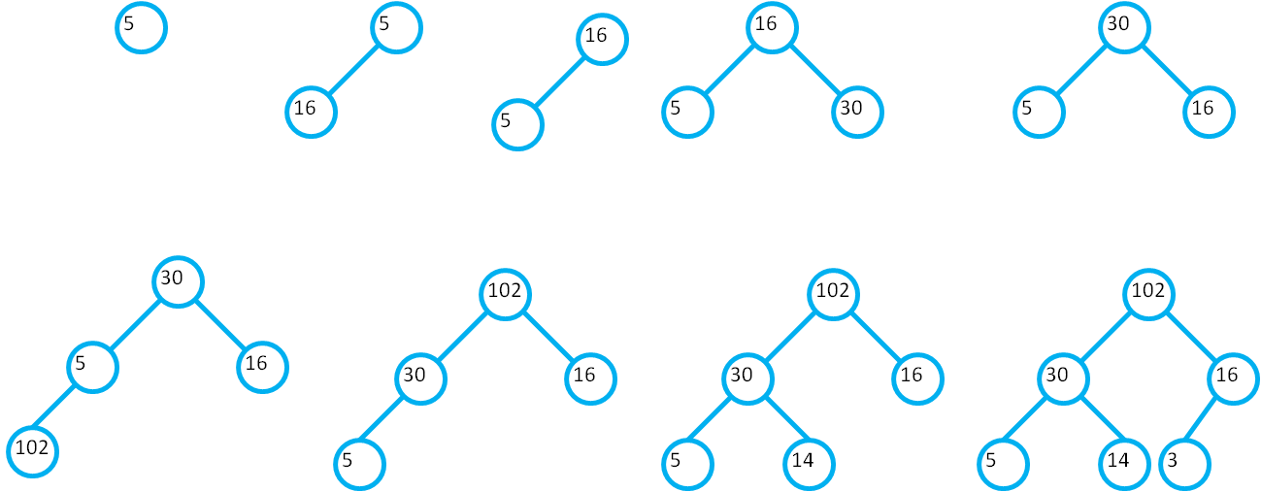

1. Given the following heap, show the resulting heap after removing 62 from the heap.



answer:



1. Consider the following list

45, 34, 342, 102, 3, 5, 35, 29, 244, 34, 7

On applying the median-of-three partitioning using quick sort, what is result of the first pass of partitioning?

answer:

**5**, 34, 342, 102, 3, **7**, 35, 29, 244, 34, **45 (median of three sorting)**

**5**, 34, 342, 102, 3, 34, 35, 29, 244, **7**, **45**

**5**, **34**, 342, 102, **3**, 34, 35, 29, 244, **7**, **45**

**5**, **3**, 342, 102, **34**, 34, 35, 29, 244, **7**, **45**

**5**, 3, 7, 102, 34, 34, 35, 29, 244, **342**, **45**

1. What is the complexity of the following program in terms of n?

for (int k = 0; k < 10000; k++) {

for (int i = 0; i < n+200; i++) {

for (int j = 0; j < n- 25; j+=2) {

System.out.print(“a”);

}

}

}

answer: O(n2)

1. Suppose your program frequently tests whether a student is in a soccer team and also need to know the student’s information such as phone number, address, and age, what is the best data structure to store the students in a soccer team?

A. ArrayList

B. LinkedList

C. Dictionary

D. LinkedList

answer: C

1. What is the binary search tree that results after inserting 45, 43, 100, 34, 23, and 3 into an empty binary search tree?

answer:

45  
 / \  
 43 100  
 /   
 34  
 /  
 23  
 /  
 3

1. What is the preorder, postorder and inorder traversal of the following tree

60  
 / \  
 15 100  
 \ / \  
 57 67 107  
 / /  
 49 64  
answer:

inorder: 15 49 57 60 64 67 100 107

preorder: 60 15 57 49 100 67 64 107

postorder: 49 57 15 64 67 107 100 60

1. What is the complexity of the following program in terms of n assuming that multiplication is a constant time operation

**double result = a;**

**int i = 1;**

**while (i <= n) {**

**result = result * result;**

**i *= 2;**

**}**

answer: O(logn)

1. Which Growth function has the highest order?

A. O(n log n)

B. O(n2)

C. O(2n)

D. O(log n)

E. O(n!)

answer: O(n!)

1. After one pass on the numbers ( 5 3 9 5 ), what would be the result if you were to use Bubble Sort?

A. 5 3 5 9  
B. 5 5 3 9  
C. 3 5 5 9  
D. 9 5 5 3

answer: C

1. After two passes on the numbers ( 5 3 9 5 ), what would be the result if you were to use Selection Sort?

A. 5 3 5 9  
B. 5 5 3 9  
C. 3 5 5 9  
D. 3 5 9 5

answer: D